January Photo Daily Challenge

Name: Mrs. Green

Period: P1-M1, P2-M2, P2-G2

Replace the “dummy” pictures in this template with each day’s assigned photo.

**SAVE AS…** **NAME_GRADE THIS_JPC**

2 – Be(YOU)tiful

**Upload to** **“Show What You Know” OR** email it to: **missy.green@asu.edu**

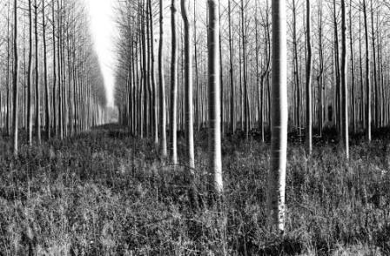

1- Brand New



4 – Picture of Family



3 – Your Hobby



6 – Picture of Laughter

5 – Picture of Hands

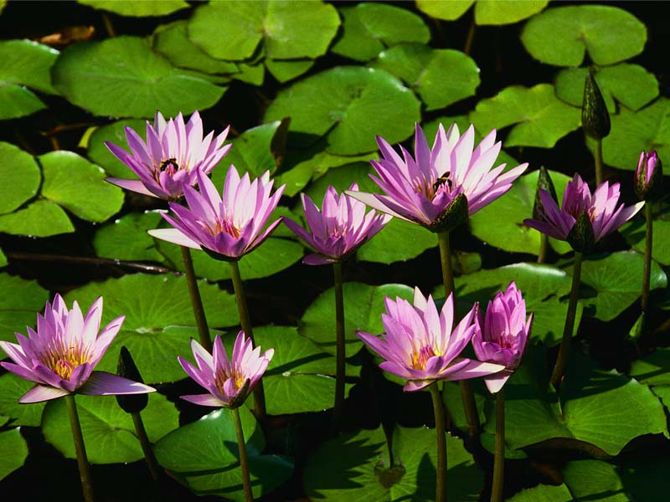





7 – Picture of your Inspiration

8 – Remember when?

9 – Where I stand

11 – Shoes

13 – Happiness

12 – Picture of something you are grateful for

10 – 10 Photos – 1 per hour throughout the day















10 – 10 Photos – 1 per hour throughout the day





14 – Picture of accomplishment

17 – My Spot

19 – Picture of Strength

18 – In my Bag

16 - Messy

15 – Picture of someone you admire





22 – Picture of Accessories

25 - Routine

24 – Reflection

23 – Sweet Dreams

21 - More

20 – Love





31 – Picture that represents Life

29 – Picture that represents a goal you have

28 – Three of a Kind

30 – Looking UP

27 - Cozy

26 - Shine