**7 & 8-Framing-Balance-Positive & Negative Space INDIVIDUAL Project**

Replace the “example” pictures in this template with your 15 best F/B/+&- pix. Review your photographs with your PT members to have them help you select the best of each required photo to include in your final document. (Read the labels above the examples.)

Name:

Class:

**Adjust the boxes as needed to fit your photographs. ALL work must be ORIGINAL and taken for this PROJECT!**

**SAVE AS…** **NAME_7_8_FBPS_Project**

**Upload to** **“Show What You Know” OR** email it to [**missy.green@asu.edu**](mailto:missy.green@asu.edu)

Framing: Connect-the-Dots

Framing: Contiguous



Framing: Contiguous

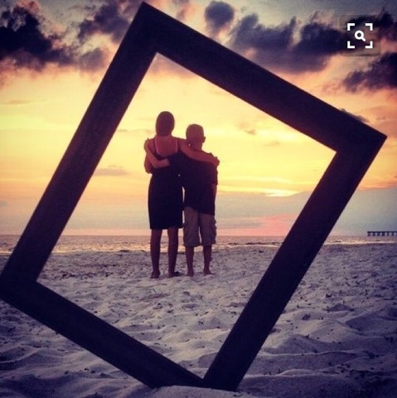

Through the: Crystal Ball

Through the: Crystal Ball

Framing: Connect-the-Dots

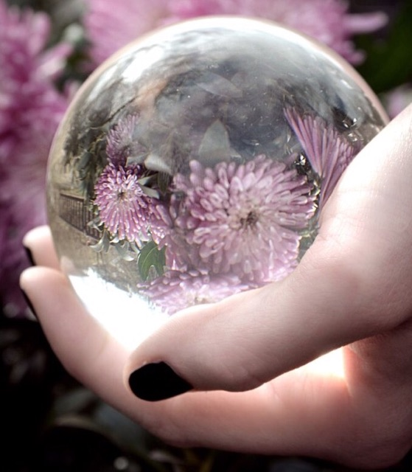

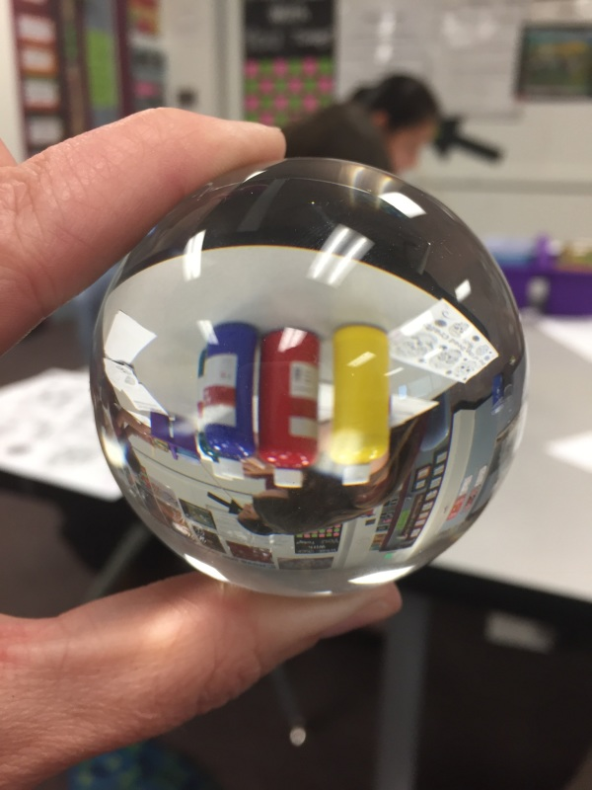

Through the: Reflective Surface

Through the: Clear Glass

Balance: Symmetrical

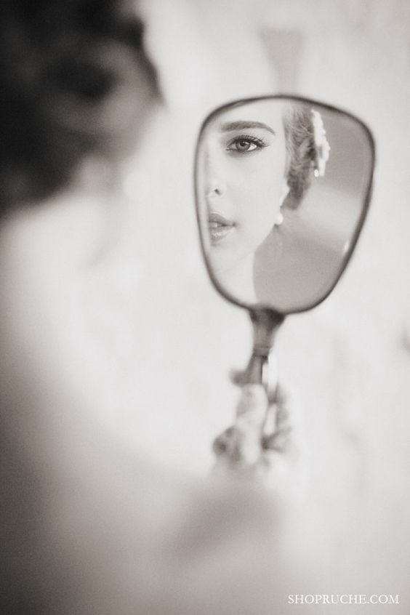

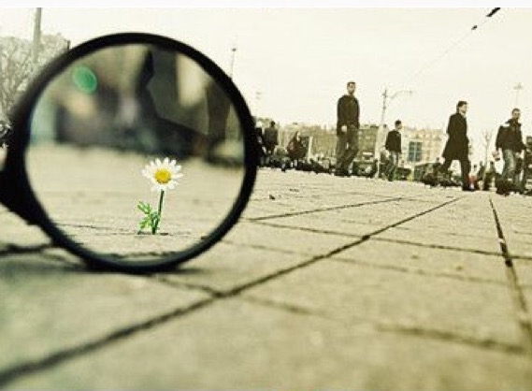

Balance: Conceptual



Balance: Tonal or Color

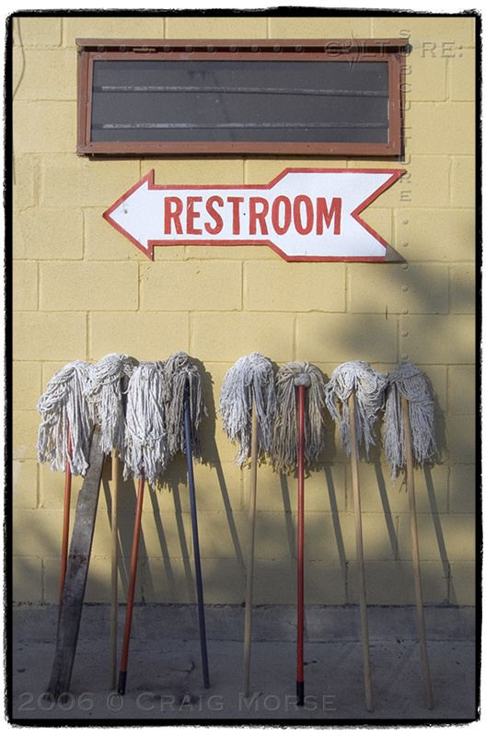

Balance: Asymmetrical

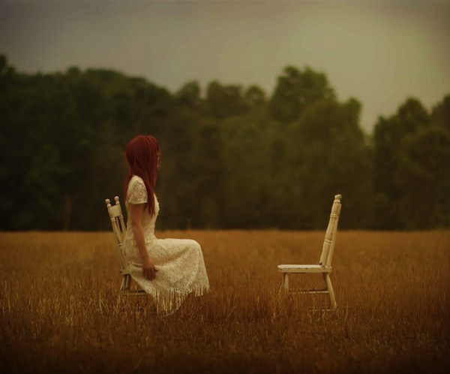

Positive-Negative Space: Use of Shadows

Positive-Negative Space: Foreground, Middle Ground, Background

Positive-Negative Space: Objects vs. Area



