February Photo Daily Challenge

Name: Mrs. Green

Period: P1-M1, P2-M2, P2-G2

Replace the “dummy” pictures in this template with each day’s assigned photo.

**SAVE AS…** **NAME_GRADE THIS_JPC**

2 – Shadow

**Upload to** **“Show What You Know” OR** email it to: **missy.green@asu.edu**

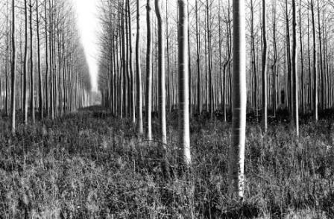

1- Something you see every morning



4 – Red



3 – I am…



5 – An inside joke

6 – Nature







7 – Something you love to wear

11 – Holding Hands

12 – Something you bought

10 – What you’re reading

9 – Blue

8 – Magic





13 – Something Sweet

16 – A Gift

15 – Something that feeds your brain

14 – The Letter “L”

18 – A person who loves you

17 – Handwriting





21 – Your View Today

24 – A furry friend

23 – Something you made

22 – A Word that describes you

20 – Share a scar

19 – Your geeky side







29 – What have you learned in 29 days?

28 – Soft

27 – A Stranger

26 - Dinner

25 – Share something beautiful