9_Black&White-Monochrome Project (Individual Project)
Replace the “dummy” pictures in this template with your examples of color images converted to black & white (grayscale) and monochrome. Select two color images to convert. Remember to adjust, crop, rotate, and resize pix as needed. Replace the “dummy” pictures in this template with your examples of 4 of your color photographs. SAVE AS… NAME_GRADE THIS_9_Black&White-Monochrome Project
Name:
Period:

Upload to “Show What You Know” OR email it to missy.green@asu.edu
REMEMBER to put YOUR NAME and CLASS PERIOD in the box!
Pattern: lines, shapes, or forms repeat and fill the frame
Original Color Image #1
Original Color Image #2

Rhythm: several points of interest cause your eyes to “flow” through the frame
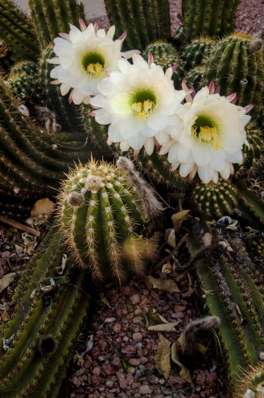
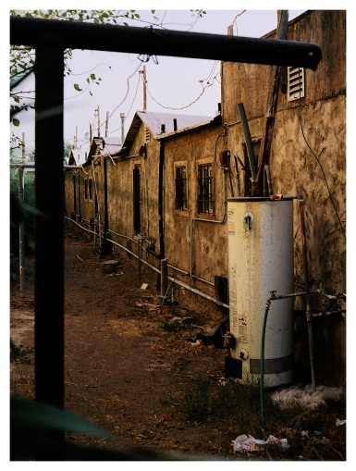
Texture: interesting surfaces (rough, shiny, bumpy, jagged, etc.) often lit from the side fill the frame
Cool spectrum monochrome of either color image

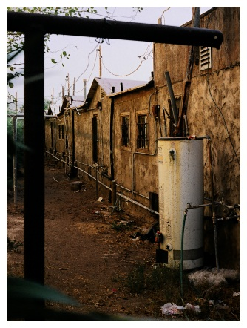
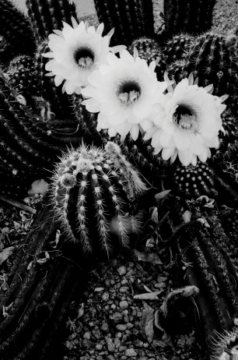
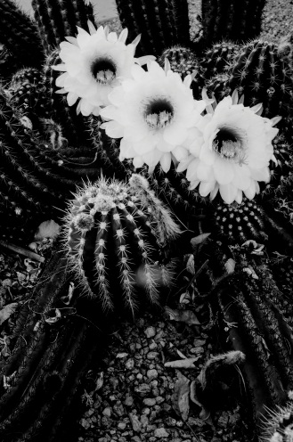
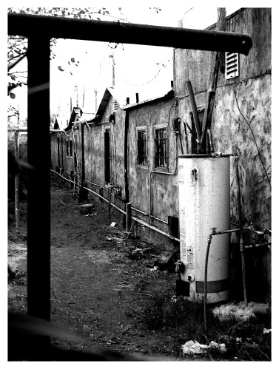
Warm spectrum monochrome of either color image

Black & White version of #1

Black & White version of #2

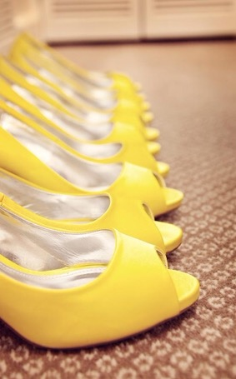
Color spectrum monochrome 2

Color spectrum monochrome 1

Pattern: lines, shapes, or forms repeat and fill the frame
Rhythm: several points of interest cause your eyes to “flow” through the frame
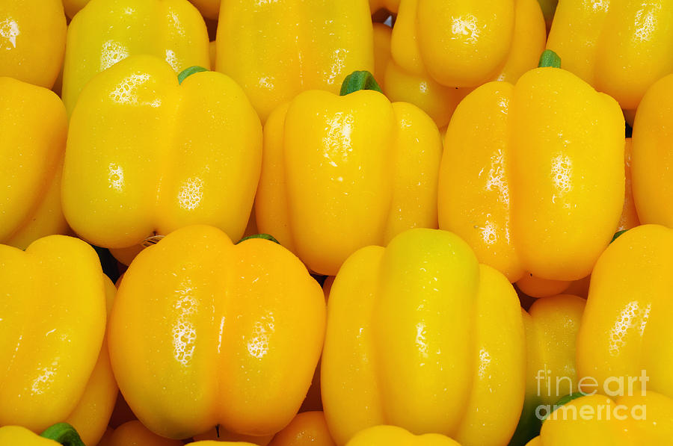
Texture: interesting surfaces (rough, shiny, bumpy, jagged, etc.) often lit from the side fill the frame

Color spectrum monochrome 3

Color spectrum monochrome 4

