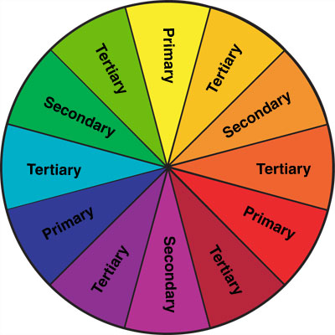
COLORS, MOOD & THEORY
Replace the “example” pictures in this template with your 8 best Color/Mood/Theory pix. Review all photographs with your PT members to select the VERY BEST photographs of each required photography TYPE based on your PT’s color to include in the final document. (Read the labels)
Adjust the boxes as needed to fit your photographs. ALL work must be ORIGINAL and taken for this PROJECT! SAVE AS… PT#_Class_7_Color_Theory_Project
Names: Click here to enter text.

PT#:
Class: Click here to enter text.

Upload to “Show What You Know” OR
email it to missy.green@asu.edu
- Include two photos for each photography TYPE
- Replace my example pix with yours.
- Change the formatting of the text boxes and picture frames... Make ‘em look GOOD!
- Give each photo a fun title. (The titles go in the boxes with the jumbled letters.)
- Each PT Member MUST submit at least 2 photographs.
- ALL photographs MUST represent your PT’s assigned COLOR
- PT Members Choice is for PT Groups of 4 students (=8 photos) – PT Groups of 3 only need to do the first 3 types (=6 pix)

Fine Art Photography
sadgasdgas
sadgasdgas
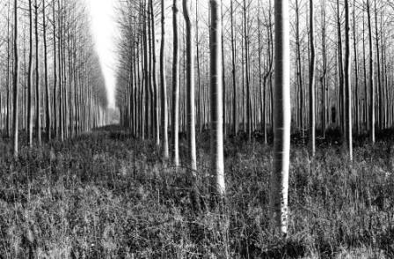
*Use the Color Symbolism Packet Info
*Each photograph must convey the “MOOD” of your color

PT Member:

PT Member:
sadgasdgas
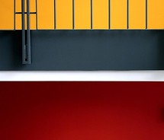
Product Photography
*Use the Color Symbolism Packet Info
*Each photograph must be an advertisement for your PT’s color THROUGH products

PT Member:
Product Photography
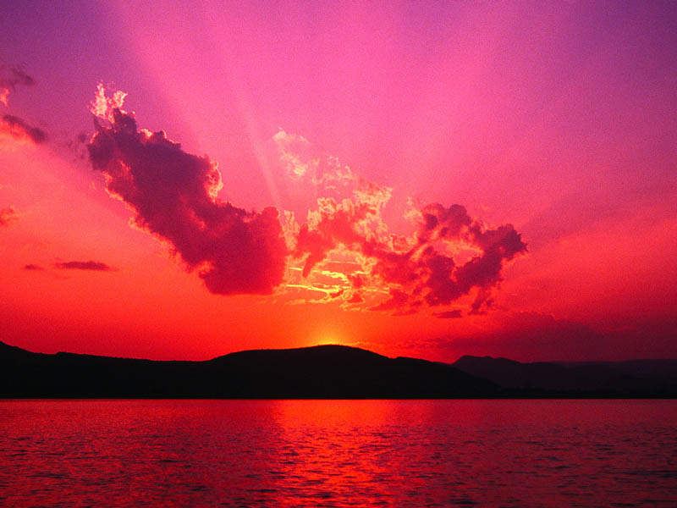
sadgasdgas
*Use the Color Symbolism Packet Info
*Each photograph must be an advertisement for your PT’s color THROUGH products

PT Member:

sadgasdgas
Stock Photography
sadgasdgas
*Use the Color Symbolism Packet Info
*Each photograph must CLEARLY convey the “MOOD” of your color
*IDEAL version of reality

Type:
PT Member:
PT Member:
PT Members
Choice
sadgasdgas
Type:
PT Member:
sadgasdgas
PT Member:

