10_Combined Composition Project
Name:
Period:

In this individual project, you will combine into a single image various composition skills you have learned so far this year. Which composition skills you combine is up to you. You will also give each photo a creative title and label which skills you used to compose the photo. All pix must be in focus, well-exposed, and cropped to clean up the “story.”
Move pix and boxes around as needed!
Here’s the rubric:
A = At least 3 of the 6 required pix have 3 combined composition skills, others with 2; 6 creative titles; easily identified and correctly labeled composition skills
B = Two pix have 3 composition skills, others have two; 6 creative titles; easily identified and correctly labeled composition skills
C = One photo has 3 composition skills; 6 creative titles; easily identified and correctly labeled composition skills
SAVE AS… NAME_GRADE THIS_10_Combined Composition
Upload to “Show What You Know” OR email it to missy.green@asu.edu
REMEMBER to put YOUR NAME and CLASS PERIOD in the box!

D = Anything less than that—but all six pix are put into the template.
F = Let’s not go there!
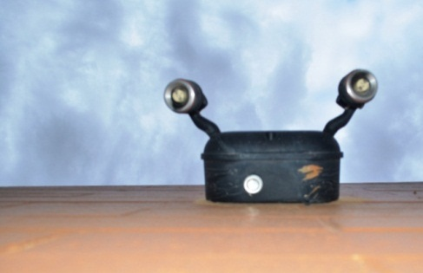
Use combinations of these composition skills:
Skills:
Skills:
Skills:
(Creative Title)

(Creative Title)

(Creative Title)

Skills:
Skills:
Skills:
(Creative Title)

(Creative Title)

(Creative Title)
Macro/POV/Rule of Thirds/Line/Shape/Form/Pattern/Rhythm/Texture/Framing/Color Schemes

